|  |  |
| --- | --- |
| Team ID | PNT2022TMID13904 |
| Project Name | CONTAINMENT ZONE ALERTING |

# DEPLOYMENT OF APP IN IBM CLOUD

DEPLOY IN KUBERNETES CLUSTER

1. Target the IBM Cloud Kubernetes Service region where you want to work.

ibmcloud cs region-set us-south

1. Set the context for the cluster in your CLI.
   1. Get the command to set the environment variable and download the Kubernetes conﬁguration ﬁles.

ibmcloud cs cluster-conﬁg cluster_kunal

* 1. Set the KUBECONFIG environment variable. Copy the output from the previous command and paste it in your terminal. The command output should look similar to the following.

> export

KUBECONFIG=/Users/$USER/.bluemix/plugins/container-service/clust ers/<

cluster_name >/< cluster_conﬁguration_ﬁle.yaml>

1. Verify that you can connect to your cluster by listing your worker nodes.

kubectl get nodes

1. Create the deployment.

kubectl create -f deployment.yaml

1. Create the service.

kubectl create -f service.yaml

1. Look at the Kubernetes dashboard from the IBM Kubernetes Service overview page.

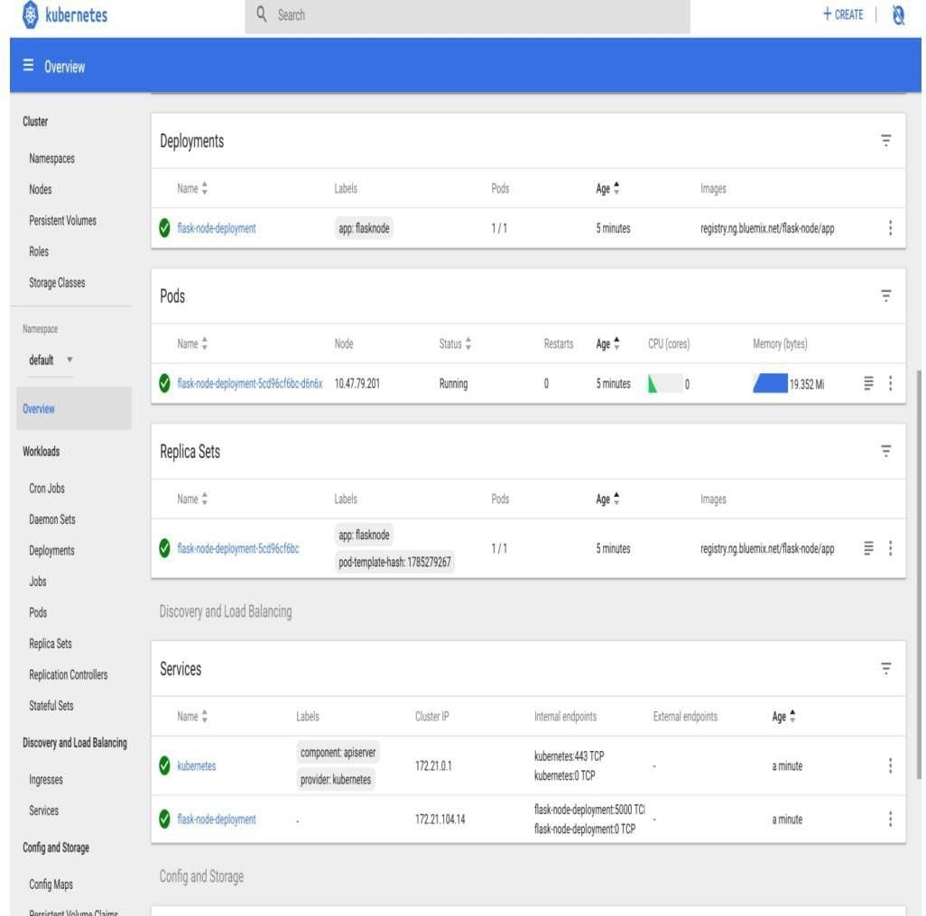

1. Finally, go to your browser and ping the Public IP of your worker node

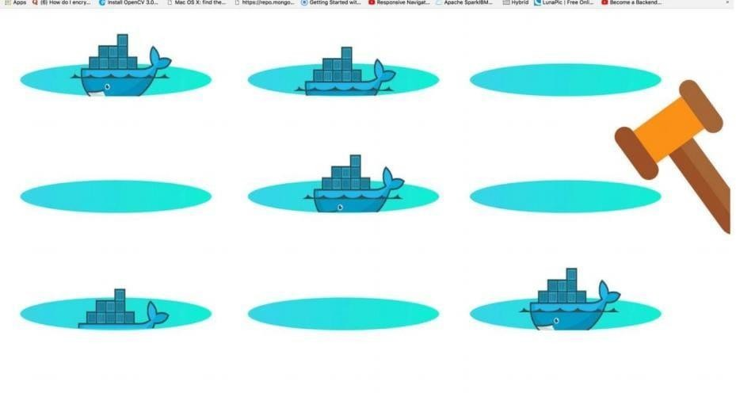

# SAMPLE:

```

$ kubectl apply -f ./deploys/k8s-deployment/deployment.yaml deployment.apps/k8s-nginx-deployment created

```

### RUN THE APPLICATION

```

$ kubectl port-forward svc/k8s-nginx-deployment 8080:80

```

### VERIFY THE APPLICATION RUNNING IN THE CLUSTER

```

$ kubectl get pods

NAME READY STATUS RESTARTS AGE

k8s-nginx-deployment-68d8f8f8f4-f4x6x 1/1 Running 0 30s

```

```

$ curl localhost:8080

<!DOCTYPE html>

<html>

<head>

<title>Welcome to nginx!</title>

<style> body {

width: 35em; margin: 0 auto;

font-family: Tahoma, Verdana, Arial